**Improving the Security and Efficiency of Competitive Examination Paper Management through Blockchain Implementation**

Sneha Baby Mathew (21BLC1236), Lisa Raj(21BLC1266), Niranjana Shaji(21BLC1264)

SENSE, VIT Chennai, Chennai, India

***Abstract—***The integrity of competitive examinations is critical to ensuring fair access to educational and career opportunities. However, in recent years, several scandals have marred the credibility of these exams, undermining public trust in the selection process. A notable example is the recent NEET UG (National Eligibility cum Entrance Test for Undergraduates) in India, where allegations of question paper leaks, impersonation, and other forms of malpractice have raised concerns about the fairness and transparency of the examination process.

***Keywords— Blockchain, AI Algorithms, Quantum Cryptography, Educational Records, Cryptography, Online Examination, Supply Chain, Smart Contracts, Immutable, Transparency, Tamper-proof, Decentralized, Competitive Examination, Efficiency, Security***

1. **INTRODUCTION**

The credibility of competitive examinations is fundamental to ensuring a merit-based system for education and career opportunities. These exams are often the gateway to prestigious institutions and careers, making their fairness and transparency crucial. However, in recent years, the integrity of such exams has been increasingly called into question due to various scandals and malpractices. A prominent example is the recent issues surrounding the NEET UG (National Eligibility cum Entrance Test for Undergraduates) in India. Allegations of question paper leaks, impersonation, and other forms of cheating have not only compromised the fairness of the exam but also shaken public confidence in the entire examination process. Blockchain technology, known for its decentralized, transparent, and tamper-proof characteristics, presents a viable solution to these issues. By recording each step of the examination process on a blockchain, from question paper generation to candidate verification and result declaration, the system can ensure that all data is immutable and verifiable by authorized parties.

# LITERATURE SURVEY

1. Apoorv Jain et al. presents an Online Examination System developed on the Ethereum blockchain platform, utilizing smart contracts along with NodeJS and MongoDB. The system eliminates the need for external equipment like data centres or cloud-based firewalls, ensuring a highly secure and authorized network. The blockchain's decentralized ledger application, which operates on proof of work, enhances security and transparency by automatically recording all transactions without third-party intervention. Additionally, the system prevents data exchange failures by stopping and destroying data upon any transaction failure. The paper underscores the critical role of smart contracts in enabling this robust and efficient examination platform.
2. Anmol Singh et al. propose a blockchain-based solution for online competitive exams using a Heterogeneous Consortium blockchain. The author developed a small-scale model to demonstrate the system's feasibility and effectiveness, highlighting its potential to provide a secure, immutable platform where tampering is not possible. However, the solution has not yet been implemented in India, which limits its current applicability.
3. Dutta, Pankaj, et al. employ a systematic review methodology, analyzing existing literature to explore the applications of blockchain technology in supply chain operations. The authors meticulously collected data from a range of academic and industry sources, focusing on how blockchain can enhance transparency, traceability, and efficiency in supply chains. The methodology is thorough in its approach, ensuring that a wide array of perspectives is considered. However, the reliance on secondary data might limit the depth of practical insights, and the paper could benefit from empirical studies or case analyses to validate the theoretical claims. Overall, the methodology is sound for a literature review, but the absence of real-world application examples may limit its impact.
4. YingliWang et al. employ a case study approach focused on a UK construction consortium piloting a smart contract initiative. The methodology combines qualitative research, including interviews and observations, with an analysis of blockchain’s potential to enhance supply chain transparency and efficiency. The study's strengths lie in its real-world application, providing practical insights into blockchain implementation, and its comprehensive analysis of both challenges and benefits. However, the focus on a single case study may limit the generalizability of the findings, and the conclusions, being based on early-stage observations, might not fully capture long-term challenges. Additionally, while the qualitative approach offers depth, it may lack the statistical rigor necessary for broader application.
5. Ashis Kumar Samanta et al. propose using Ethereum's blockchain to create smart contracts that automate agreements between buyers and sellers, eliminating the need for intermediaries. The methodology effectively enhances transparency and security, addressing issues like fraud and double spending through cryptographic techniques and decentralized consensus. While this approach reduces transaction costs and increases trust, it also faces challenges such as scalability issues, high computational costs, and the complexity that may hinder adoption in traditional e-commerce settings.
6. Ocheja, Patrick, et al. conduct a bibliometric study to understand the evolution of research in blockchain and education, utilizing the Web of Science and Scopus databases for their structured journal classification systems. The study highlights recent advancements in bibliometric analysis tools compatible with these databases. By employing keywords such as "blockchain," "education," "lifelong learning," and "digital certificate," the authors gathered relevant articles and conducted an analysis that revealed a significant focus on using blockchain technology for issuing and verifying academic certificates. The study also identified a gap in the discussion of standardization within the field. A qualitative review of 47 milestone articles indicates a trend towards credential-related blockchain research, suggesting the need for broader exploration and standardization in educational applications of blockchain technology.
7. Rustemi, Avni, et al. present a systematic review of blockchain-based systems for academic certificate verification, analyzing research conducted between 2018 and 2022. Using the PRISMA framework, the authors identified 34 relevant studies from an initial pool of 1744 papers. The research is categorized into six major themes, highlighting gaps that require further exploration. The survey critiques earlier works for their lack of a structured review protocol and emphasizes the necessity of a rigorous Systematic Literature Review (SLR) methodology. The paper offers recommendations for future research and practical applications, providing valuable insights for researchers, policymakers, and practitioners in the field.
8. Agarwal, Udit, et al. examine the integration of Blockchain Technology (BC) in Supply Chain Management (SCM) through a comprehensive review. The authors analyzed 445 papers from various databases, ultimately selecting 97 relevant studies published post-2016. Key contributions include works by Huang (2021), Chang and Chen (2020), Tönnissen and Teuteberg (2020), Vadgama and Tasca (2021), and Gonczol et al. (2020), which explore the development, potential applications, and impact of BC technology on SCM. The selected literature emphasizes the secure management of supply chains and the adoption of BC technology, providing a detailed understanding of its benefits and challenges within SCM.
9. Abdelsalam, Mohamed, Amira M. Idrees, and Marwan Shokry explore the integration of blockchain technology with online examination systems to enhance security and reliability. The paper discusses the significant shift towards e-learning due to the COVID-19 pandemic, which has underscored the need for secure and efficient online assessment methods. Previous studies, including those by Al Rawashdeh et al. (2021) and Eltahir et al. (2022), have highlighted the benefits and challenges of e-learning, particularly in the context of e-exams during the pandemic. Additionally, the paper references advancements in blockchain technology, with a focus on its architecture and future trends, as detailed by Zheng et al. (2017), which promise improved transparency and security. The proposed model in this research integrates blockchain with the Moodle LMS and an auto-grading system, aiming to overcome the limitations of centralized exam systems by utilizing the decentralized nature of blockchain for a more trustworthy academic assessment process.
10. Li, Hongzhi, and Dezhi Han discuss the growing importance of securely storing and sharing educational records, particularly with the introduction of blockchain technology. Previous studies have examined various methods for secure data storage, focusing on challenges related to data integrity, privacy, and accessibility. Blockchain technology, with its decentralized and immutable characteristics, offers promising solutions to these challenges. Several approaches have been proposed to leverage blockchain for educational data management, addressing issues such as tampering, unauthorized access, and fraud. Significant advancements include the integration of smart contracts and distributed ledger technologies to improve the security and efficiency of educational record-keeping. Building on these foundational studies, this paper proposes a blockchain-based scheme, EduRSS, specifically designed for the secure storage and sharing of educational records, addressing the limitations of traditional systems and recent blockchain implementations.
11. Muhammad Shoaib Farooq1 et.al (2021) introduced model contains three types of networks of nodes:-(1) Management network:This network will consist allmanagement nodes of educational institutes. (2) Instructor network: An instructor will be assigned by the  
    management nodes to a particular course. (3) Learner network: This network will contain all student nodesof a specific course. The learner nodes will be able to getaccess to course material and give assigned exams. But Scalability and generalizedstandardizationtake off a lot of loads from the blockchainand the storage issue would be handled.
12. Nasir Khan et.al (2024)introduced a model framework encompasses the integration of blockchain  
    technology, AI algorithms, and quantum-resistant cryptography to enhance trust, security,  
    and efficiency within educational systems. The design phase involves defining data  
    structures, cryptographic protocols, smart contract logic, and user interfaces that comprise  
    the proposed solution. Legal issues and compliance issues are some of the common challenges faced.
13. Farhan Ali et.al (2024) introduced a model comprehensively explore the educational security evolution facilitated by blockchain, AI, and quantum cryptography solutions, a multi-faceted methodology encompassing literature review, case study analysis, and expert interviews was employed.Security ,Ethical and Societal Implications are some of the major drawbacks of this model.
14. Ann heng.et al(2024)introduced a model that encompasses a comprehensive review of existing literature, empirical analysis of case studies, and qualitative insights from experts in relevant fields. By synthesizing insights from diverse sources, this study aims to provide a nuanced understanding of the opportunities and challenges associated with leveraging emerging technologies for educational integrity. Technology complexity and cybersecurity risks are the major issues found in this model.
15. Juan.et al(2024) introduced a model that integrates dual blockchain architecture, smart contracts, andzero-knowledge proofs to offer a scalable and transparent framework aimed at  
    reducing fraud and improving the mobility and opportunities for students and  
    professionals worldwide. Consensus Delays and Transaction finality are the issues found in this model.
16. **ARCHITECTURE**

The blockchain architecture utilized in this project is based on the Ethereum network, chosen for its robust support for smart contracts and decentralized application development. The decentralized nature of Ethereum ensures that examination data is securely recorded and immutable once stored. By leveraging Ethereum, the system ensures transparency and tamperproof management of examination records, preventing any unauthorized alterations. In this architecture, smart contracts play a central role, automating tasks such as examination creation, participant management, and result recording. These contracts, written in Solidity, enforce strict access control mechanisms, ensuring only authorized individuals can interact with the system. The immutability of these contracts adds a layer of security, as the rules governing the system cannot be changed after deployment**.** A hybrid approach is adopted for data management, where sensitive examination data is stored off-chain, and only cryptographic hashes of the data are stored on-chain. This off-chain storage improves efficiency and scalability, while the on-chain hashes provide a secure method for verifying the integrity of the stored data. This approach strikes a balance between security and practicality, preventing the blockchain from becoming overloaded with large datasets. For consensus, Ethereum’s current Proof-of-Work (PoW) mechanism ensures that all transactions are validated securely. As Ethereum transitions to Proof-of-Stake (PoS), the efficiency of the network is expected to improve further. In a permissioned environment, such as a consortium of educational institutions, the architecture could adopt more efficient consensus mechanisms like Practical Byzantine Fault Tolerance (PBFT) to enable faster transactions while maintaining trust among participating entities. This architecture emphasizes security, transparency, and scalability, making it suitable for managing sensitive examination processes, ensuring the integrity of the data without sacrificing performance or privacy.

1. **METHODOLOGY**

1. **Smart Contract Development**

The backbone of the blockchain-based examination platform is the ExamPlatform.sol smart contract, written in Solidity. This contract manages core functionalities such as recording exam details, managing participants (e.g., examiners, students), and ensuring the integrity of the examination process. The smart contract contains functions to add and retrieve examination records, with built-in mechanisms to guarantee that only authorized users can access or modify these records. Additionally, it uses Ethereum's decentralized nature to prevent any tampering with the data. Solidity was chosen for its compatibility with Ethereum, allowing for seamless deployment on Ethereum Virtual Machine (EVM)-compatible networks.

1. **Migration and Deployment Process**

The migration process involves deploying the smart contract onto a blockchain network, which in this case is a locally simulated Ethereum blockchain via Ganache. To facilitate deployment, a migration script is created in the migrations folder. This script leverages Truffle's migration system, which enables the sequential deployment of smart contracts and ensures that anyupdates to the contract are reflected in the deployment process. After creating the migration script, Truffle is used to execute the deployment, which compiles the contract into bytecode that can be executed by the Ethereum network. The migration process initializes the smart contract and stores it on the blockchain, making it accessible for interaction.

1. **Configuration for Local Blockchain Deployment**

The project connects to a local Ethereum blockchain instance running on Ganache. Ganache simulates a blockchain environment and provides a local network for testing smart contracts before deploying them to a public or private Ethereum network. The configuration file truffle config.js is updated to point to Ganache’s default settings (localhost on port 7545). This allows the smart contract to be deployed on the local blockchain, enabling testing and interaction without any real-world financial costs. Additionally, the Solidity compiler version is specified to ensure that the contract is compiled using the correct version of the language, thus avoiding compatibility issues. By using a local blockchain, developers can rapidly iterate on the contract’s functionality, making modifications and redeploying as necessary. This setup allows for efficient testing of the contract’s logic and interactions with other components of the system.

1. **Backend Integration**

The backend interaction with the blockchain is handled using web3.js, a JavaScript library that allows web applications to interact with Ethereum nodes. The app.js file sets up the connection between the web interface and the deployed smart contract. The backend manages requests such as adding new exams, verifying exam data, and retrieving results by invoking functions within the smart contract. This backend communication is crucial for allowing users to interact with the smart contract through a user-friendly interface. The web application connects to the Ethereum blockchain using web3.js, which retrieves the contract’s ABI (Application Binary Interface) to interact with its functions. The ABI serves as the interface between the contract and the external application, defining how data is sent to and received from the smart contract.

1. **Smart Contract Interaction**

Smart contract interaction is further facilitated through the interact.js script, which enables command-line interaction with the deployed smart contract. This script demonstrates how external scripts can interact with the smart contract by calling its functions programmatically. It establishes a connection to the Ethereum network, retrieves contract data, and allows for various operations to be executed, such as adding exams or retrieving exam results. The interaction process is automated, allowing for secure transactions to be recorded on the blockchain. Once deployed, the smart contract’s immutable nature ensures that any examination data stored cannot be altered without proper authorization, thus maintaining the integrity and transparency of the system.

1. **Ganache and Truffle Integration**

Ganache is used to simulate the Ethereum environment for the local deployment of the smart contract. It provides developers with the ability to create and manipulate blockchain transactions without needing a live Ethereum network. This local blockchain environment mimics the behavior of the Ethereum mainnet or testnet, but without the financial and operational overhead. Once Ganache is configured, the smart contract is deployed to this local blockchain using Truffle. This deployment process creates an address for the contract, allowing it to be interacted with via the front-end or external scripts. The contract address is essential for establishing a point of reference on the blockchain for all future interactions. During the deployment, the contract undergoes two phases: compilation and migration. In the compilation phase, the Solidity code is transformed into bytecode and stored in the build directory. The migration phase involves deploying the bytecode to the blockchain, registering it with a contract address, and making it available for subsequent interactions.

1. **Testing and Interaction**

Once the contract is deployed on Ganache, various interactions and testing processes are performed using Truffle and web3.js. Truffle enables contract function calls through its command-line interface, allowing the development team to execute unit tests, invoke contract functions, and ensure the system operates as expected. Moreover, web3.js is integrated into the front-end and external scripts to allow users to interact with the contract in real-time. Through this, users can input data (such as exam results) and retrieve stored information from the blockchain. The integration of web3.js into the system ensures a smooth flow of data between the decentralized contract and the end-user interface.

1. **Additional Considerations**

• Security Measures: Implement security best practices in your smart contract and backend code to protect against common vulnerabilities.

• Scalability: Design the backend to handle a large number of simultaneous interactions with the blockchain, ensuring it can scale as the number of users grows.

• User Authentication: Integrate user authentication mechanisms to ensure that only authorized users can interact with the smart contract.

• Logging and Monitoring: Implement logging and monitoring to track interactions with the smart contract, which can help in debugging and auditing. By incorporating these details, we have created a comprehensive and robust blockchain-based examination platform. This platform ensures the integrity and transparency of the examination process, leveraging the decentralized nature of blockchain technology.

1. **RESULTS**

**Fig1**

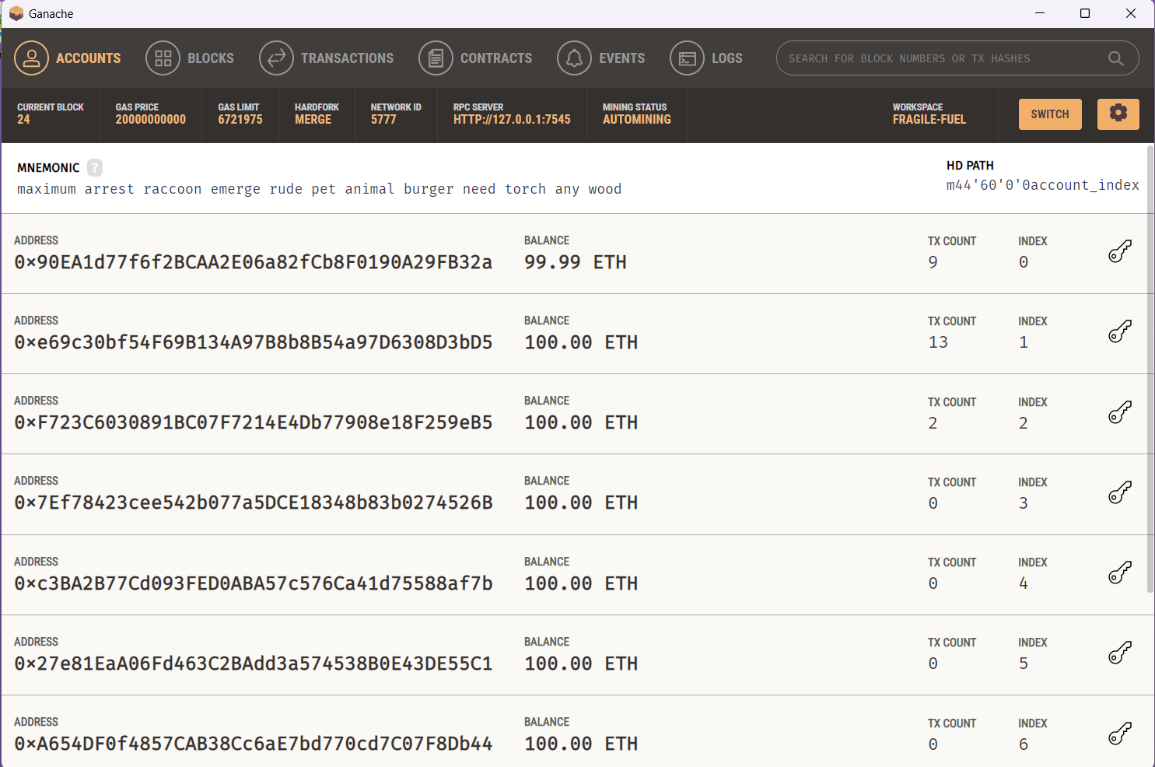Ganache Main Screen: Fig1 shows the primary interface of Ganache, an Ethereum blockchain development tool. It presents the key information, including the status of accounts, block numbers, and the gas used per transaction, aiding in the simulation of the blockchain network.

**Fig2**

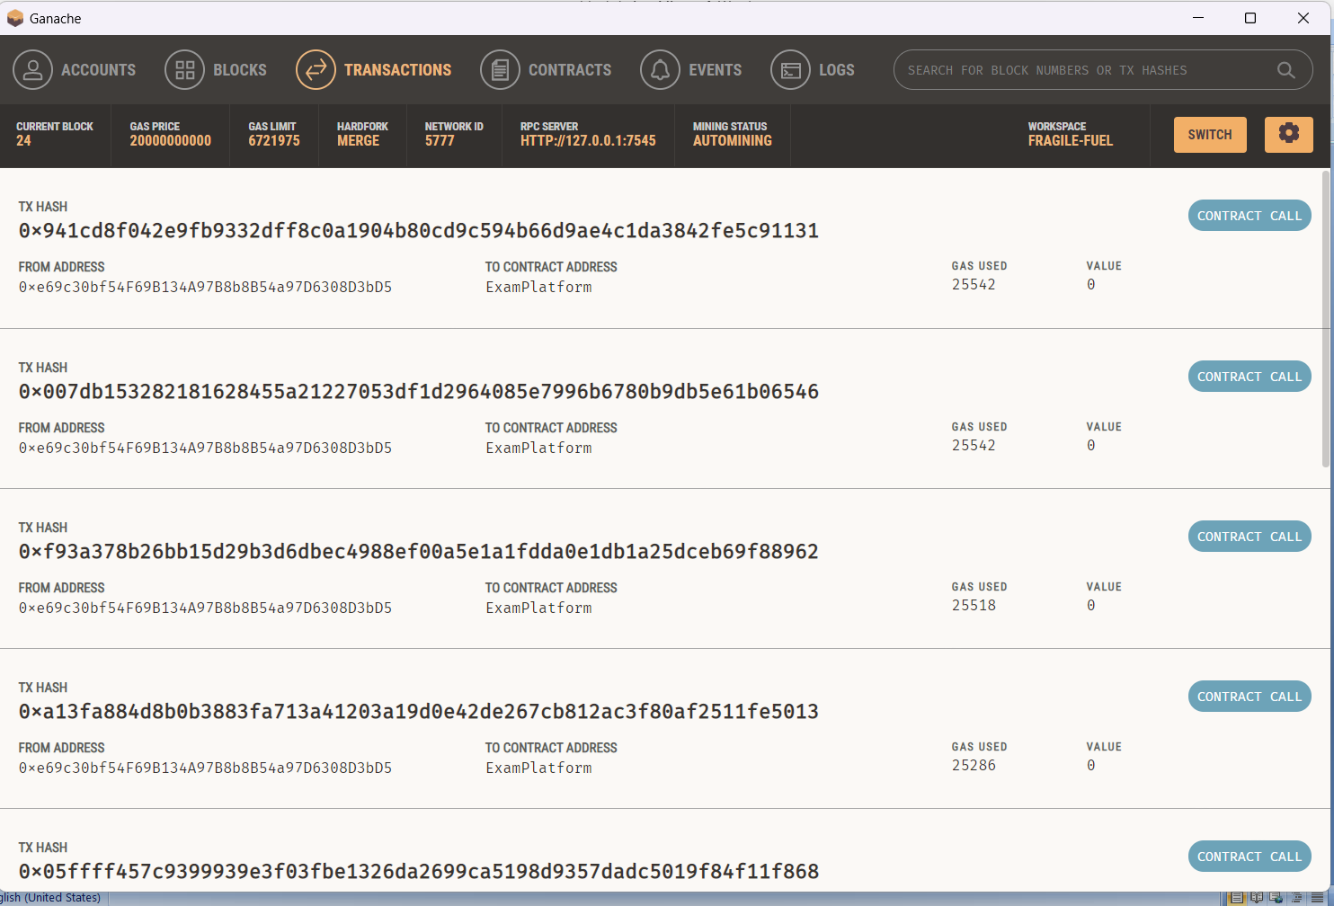Transactions After Each Block is Created: Fig2 captures the transaction records after each block creation. It displays the sequential addition of blocks and the detailed transaction logs, providing a clear representation of how data is immutably stored on the blockchain.

**Fig3**

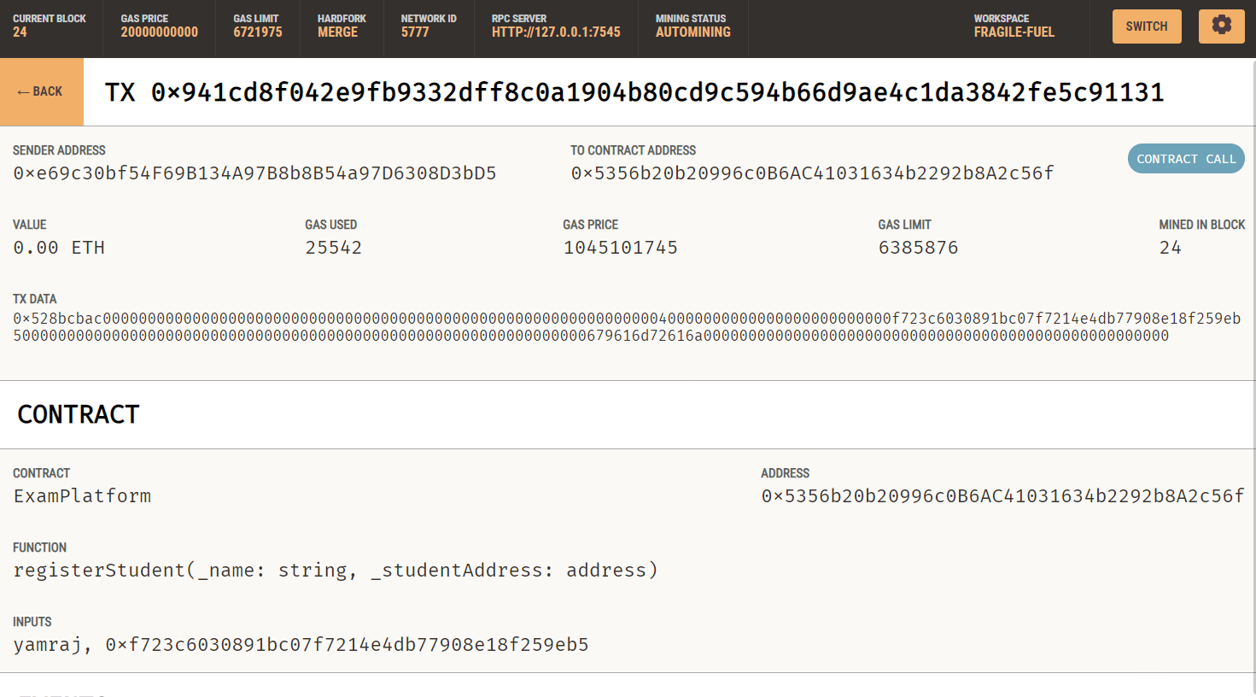Successful Student Registration Transaction in Ganache: Fig3 represents the successful transaction of student registration in Ganache. It shows the confirmation of the transaction, ensuring that the student details were securely added to the blockchain and recorded immutably.

**Fig4**

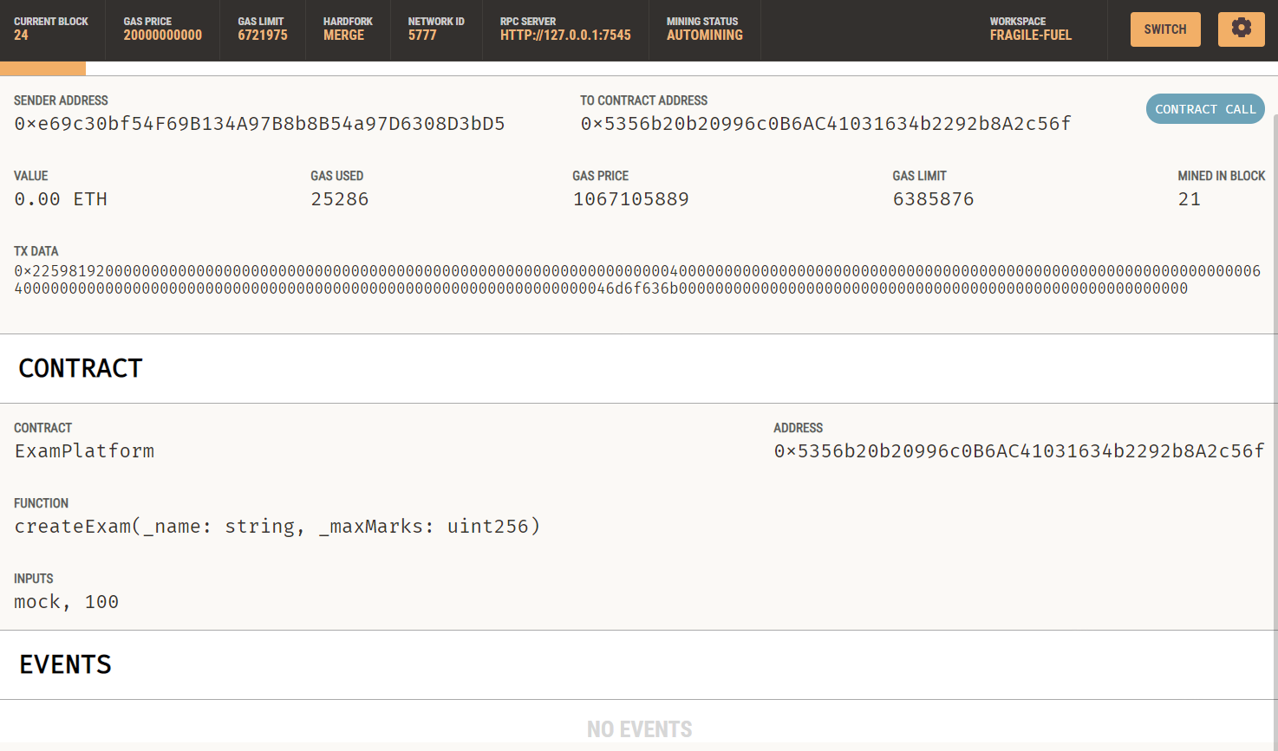Successful Exam Creation Transaction in Ganache: Fig4 illustrates the successful creation of an exam in Ganache. It

shows the confirmation of the exam setup, securely logged on the blockchain, ensuring that no unauthorized changes can be made.

**Fig5**

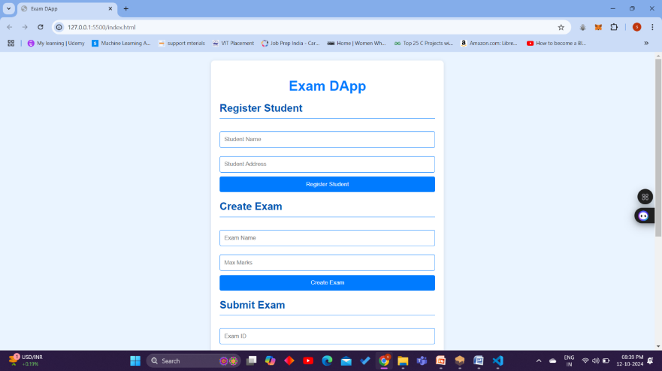

**Fig6**

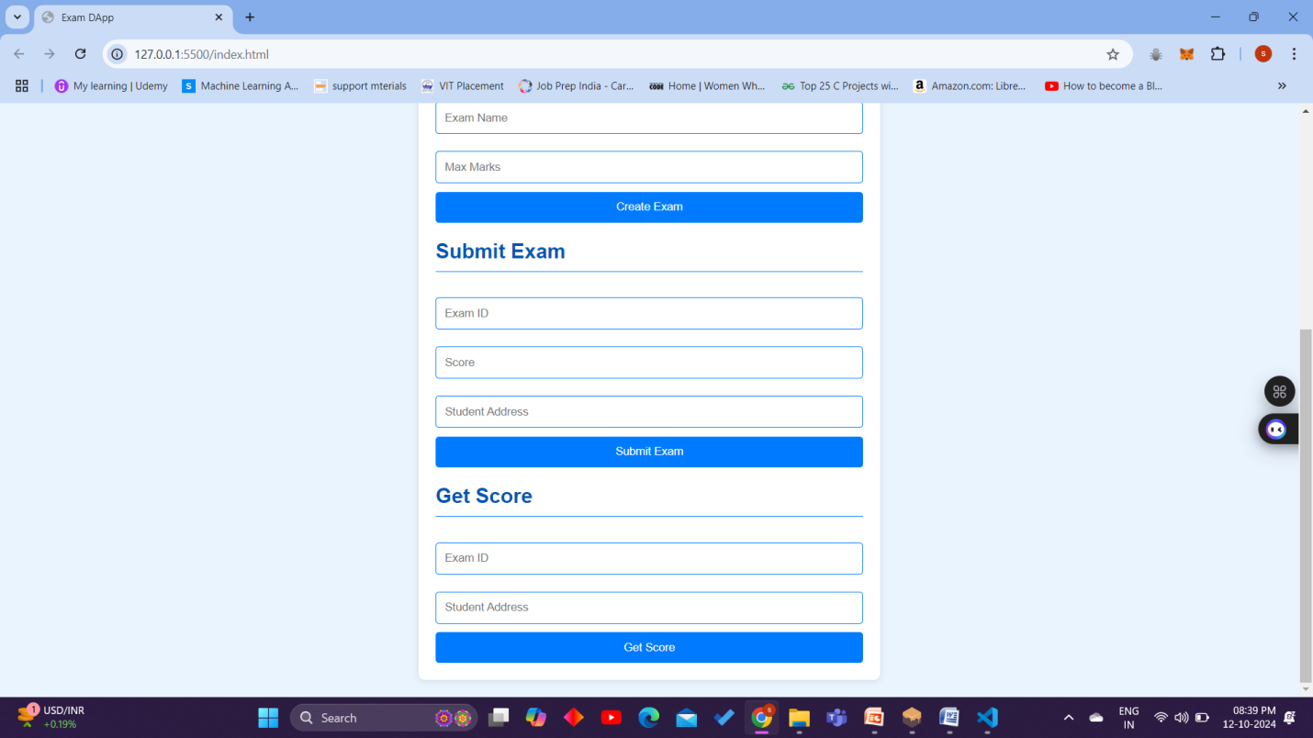Final Front-End Integration: Fig3 and Fig6 The image depicts the fully integrated front-end user interface, showcasing how the blockchain interacts with users for actions like registration and transaction confirmations, ensuring a user-friendly interaction with the backend blockchain infrastructure.

**Fig7**

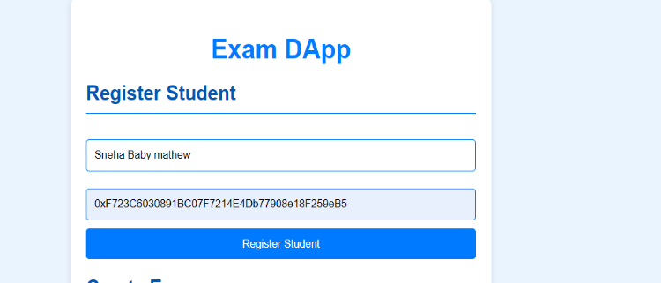

**Fig8**

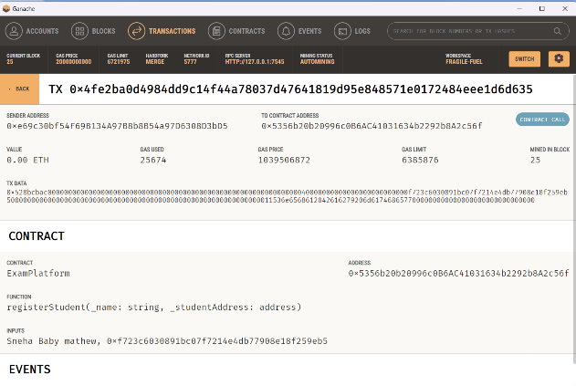Sample Registration and Transaction Log: fig7 and fig8 demonstrates the sample registration process, followed by the logging of transactions in the blockchain. It highlights how the system records each event, ensuring secure, immutable records within the blockchain ledger.

1. **CONCLUSION**

This project demonstrates the design and implementation of a decentralized examination platform using Ethereum blockchain technology. By utilizing smart contracts, the platform ensures a high level of security, transparency, and immutability. The integration of Truffle, Ganache, and web3.js creates an efficient development cycle, allowing for local testing, rapid deployment, and seamless interaction with the blockchain. This system could be extended to handle larger datasets and deployed on a public blockchain, further improving scalability and reliability.

1. **REFERENCES**

[1] Jain, A. Kumar Tripathi, N. Chandra and P. Chinnasamy, "Smart Contract enabled Online Examination System Based in Blockchain Network,"

[2] Singh, Anmol. "Design, Analysis and Implementation of Online Competitive Examination Using Heterogeneous Consortium Blockchain."

[3] Dutta, Pankaj, et al. "Blockchain technology in supply chain operations: Applications, challenges and research opportunities." Transportation research part e: Logistics and transportation review 142 (2020): 102067.

[4] Wang, Yingli, Catherine Huirong Chen, and Ahmed Zghari-Sales. "Designing a blockchain enabled supply chain." International Journal of Production Research 59.5 (2021): 1450-1475

[5] Samanta, Ashis Kumar, Bidyut Biman Sarkar, and NabenduChaki. "A blockchain-based smart contract towards developing secured university examination system." Journal of Data, Information and Management 3 (2021): 237-249.

[6] Ocheja, Patrick, et al. "Blockchain in education: A systematic review and practical case studies." IEEE Access 10 (2022): 99525-99540.

[7] Rustemi, Avni, et al. "A systematic literature review on blockchain-based systems for academic certificate verification." IEEE Access 11 (2023): 64679-64696.

[8] Agarwal, Udit, et al. "Blockchain technology for secure supply chain management: A comprehensive review." Ieee Access 10 (2022): 85493-85517.

[9] Abdelsalam, Mohamed, Amira M. Idrees, and Marwan Shokry. "A proposed model for improving the reliability of online exam results using blockchain." IEEE Access (2023).

[10] Li, Hongzhi, and Dezhi Han. "EduRSS: A blockchain-based educational records secure storage and sharing scheme." IEEE access 7 (2019): 179273-179289.

[11] Farooq, Muhammad Shoaib, Rabia Tehseen, and Uzma Omer. "Blockchain based online examination assessment models for educational institutes: a systematic literature review." VFAST Transactions on Software Engineering 9.3 (2021): 57-67.

[12] Farooq, Muhammad Shoaib, Rabia Tehseen, and Uzma Omer. "Blockchain based online examination assessment models for educational institutes: a systematic literature review." VFAST Transactions on Software Engineering 9.3 (2021): 57-67.

[13] Ali, Farhan, and Eric Lancon. "Educational Security Evolution: Blockchain, AI, and Quantum Cryptography Solutions."

[14] Heng, Ann. "Educational Integrity in the Digital Age: Blockchain, AI, and Quantum Cryptography." (2023).

[15] Moya, Juan A. Berrios. "Blockchain for Academic Integrity: Developing the Blockchain Academic Credential Interoperability Protocol (BACIP)." arXiv preprint arXiv:2406.15482 (2024).